


Intellectual Property

AEROSPACE

In a little over 20 years Barker Brettell has built a global reputation working within the aerospace sector to provide patent support, devising bespoke IP programmes which make a positive difference to our clients' bottom line.
Our 19-strong team of aerospace-experienced attorneys has over 100 years of collective aerospace experience.

We're speaking the same language.
We 'get' aerospace.
We get to know clients, their patent systems, and commercial objectives.
We provide attorney and paralegal secondments, and if you need an EPO opposition filing, or an invention-mining workshop or brainstorming 'design around' session to set up, we have the know-how and experience to make it happen.

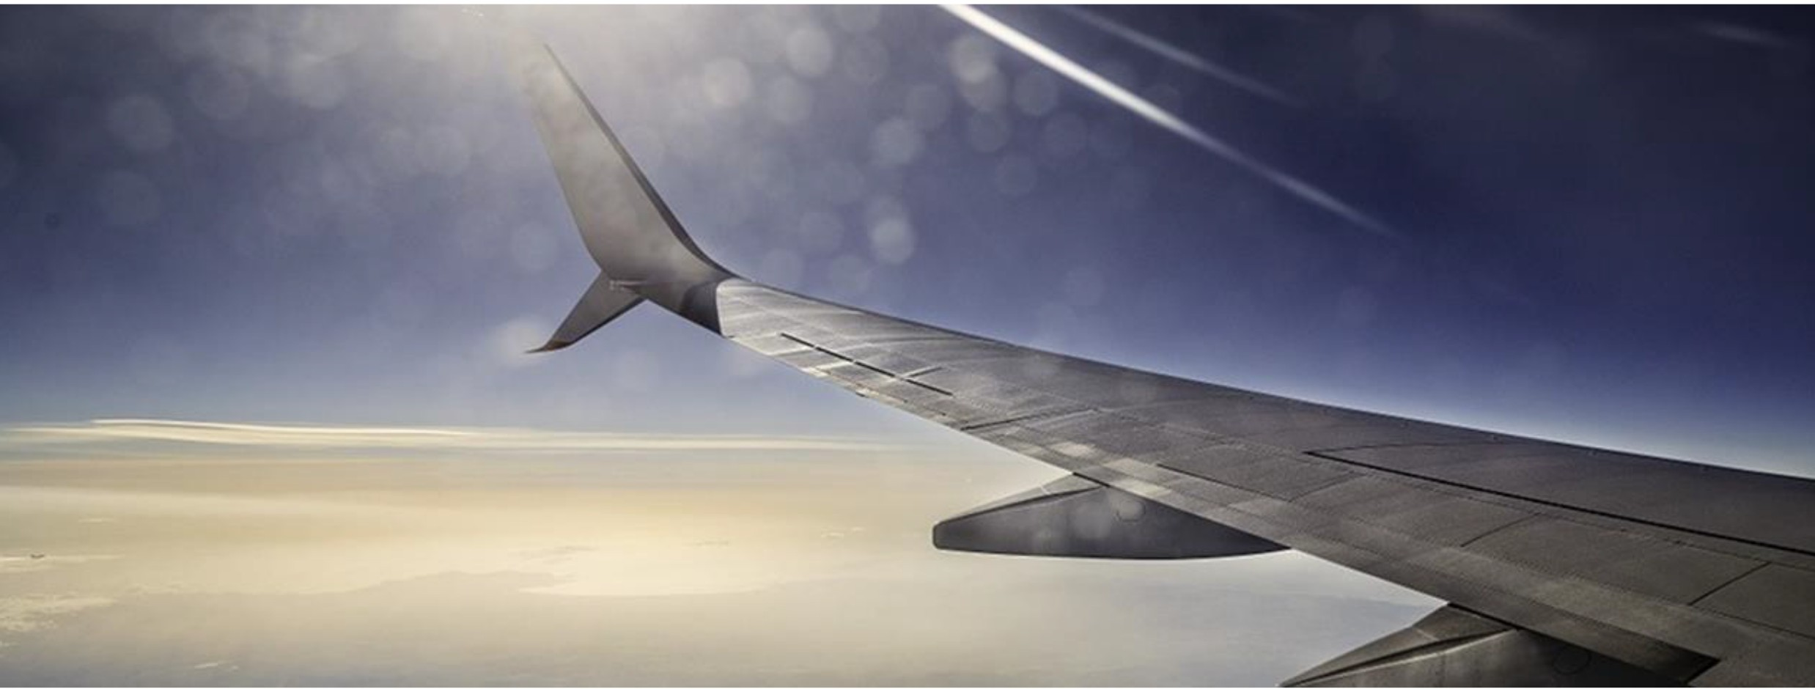
CLIENTS
Our clients include OEM giants and also suppliers, and although due to the nature of the industry we are unable to mention some of them directly, they include a major helicopter manufacturer, a military jet aircraft manufacturer, a European manufacturer of nacelles for aircraft, a Japanese avionics company, a UK aircraft safety systems supplier, and a UK-based global leader in gas turbines.

OUR SECTOR EXPERIENCE MEANS CLIENTS BENEFIT FROM:
- Our ability to work side-by-side with you to design and implement bespoke streamlined procedures that fit in with your systems to ensure that the process of getting a patent from filing to grant is prompt and economical
- A close working relationship with European Patent Office examiners, and understanding their drivers and pressure points, to ensure that client success rates are high
- The size and flexibility of our aerospace team and the wider resource of the firm to offer attorney and paralegal secondments, opposition programmes, invention-mining workshops, and brainstorming 'design around' sessions

WE HAVE HELPED CLIENTS ACROSS THE SECTOR BY:
  - Filing oppositions against competitor patents, and defend oppositions to the client's patents
  - Fast-tracking and securing over 100 patents granted at the EPO on accelerated examination programmes
  - Placing several attorneys on long-term, in-house secondments to support a period of exponential workload
  - Placing an attorney on an overseas liaison project with a large aerospace company for a month
  - Creating a tailor-made reporting system after carrying out due diligence on internal procedures, decision makers and decision making points. This dovetailed with the in-house systems, ensuring minimal disruption for the in-house counsel, paralegals, and accounts departments
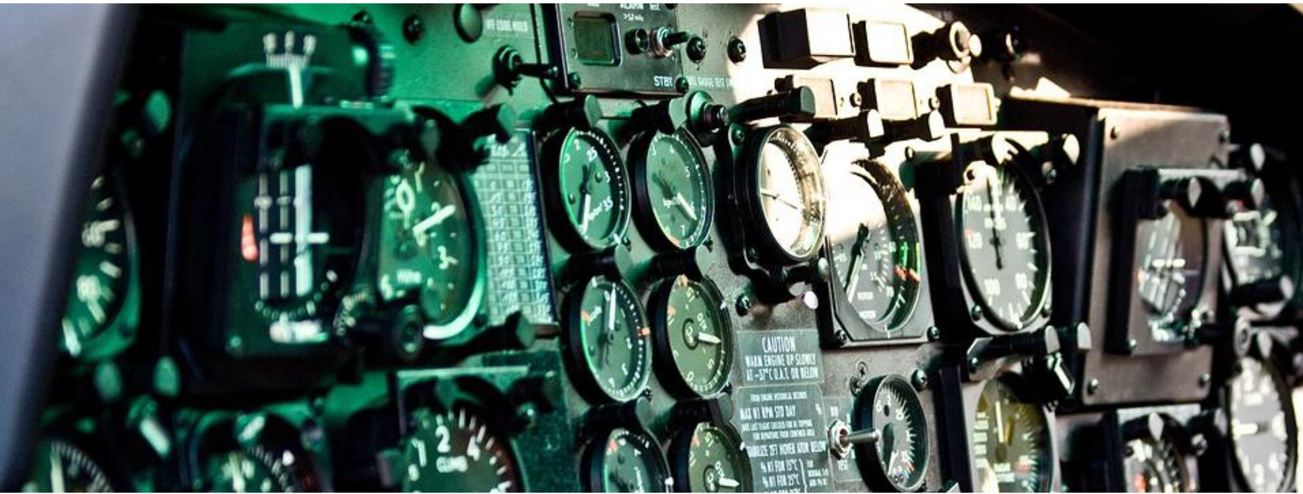
Above all, we work hard for all our clients. Big or small. From OEM companies to suppliers, universities to small startups.

EXPERIENCE HIGHLIGHTS
- Helped an SME file a patent on an aerospace feature. A major airline started using a similar feature, assuming that the patent would not be granted and refused to discuss the issue. We adopted a strategy of pushing through the patent in Europe and the USA before re­ approaching the airline, which resulted in a short licensing discussion involving a substantial payment of back-royalties. The feature has now been successfully adopted by over 100 airlines, generating further income for the client
- Extensive experience of prosecuting applications relating to flight control systems, guidance systems, imaging systems, cockpit instrumentation, manufacturing techniques, composite materials, rotor assemblies and fuel heaters. Our attorneys have worked with imaging, radar and cooling electronics, engine design, aircraft control surfaces and engine control systems, landing systems, and aircraft safety systems
- The team is currently working with a major helicopter manufacturer on its European patent portfolio
- Drafting and prosecuting applications for a leading UK aerospace manufacturer

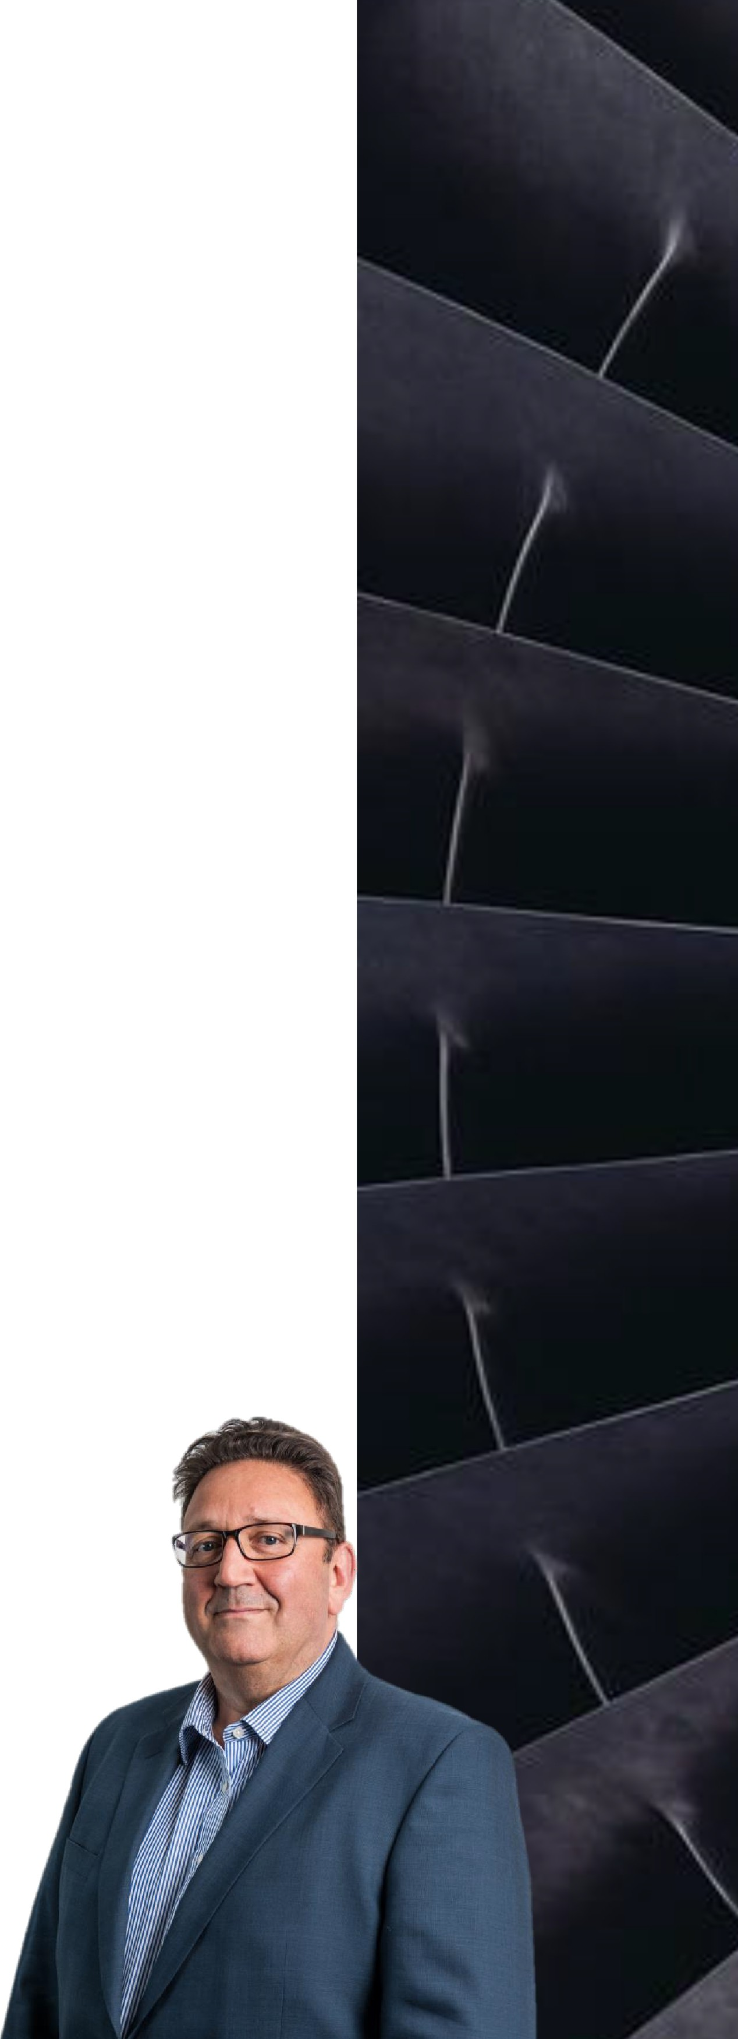

RECOGNITION





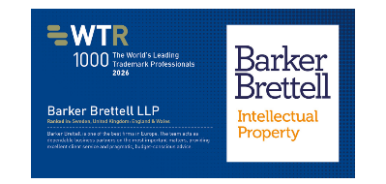




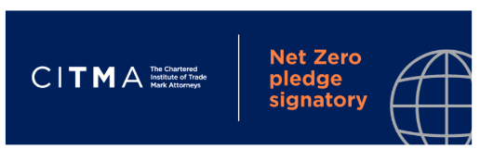

- Shortlisted for IP Awards 2026 – Managing IP
- Top Tier Firm 2026 – Legal 500
- Ranked in Sweden, United Kingdom: England & Wales – WTR 100
- Ranked as a Top Tier Firm for 10+ years – IP Stars 2026
- Ranked as a Recommended Firm – IP Stars 2026
- Cyber Essentials Certified Plus
- CITMA – Net Zero Pledge Signature

Key contact:
John Lawrence
Senior Partner & Patent Attorney
Head of Aerospace
Tel: +44(0)121456 0006
john.lawrence@barkerbrettell.co.uk barkerbrettell.co.uk

